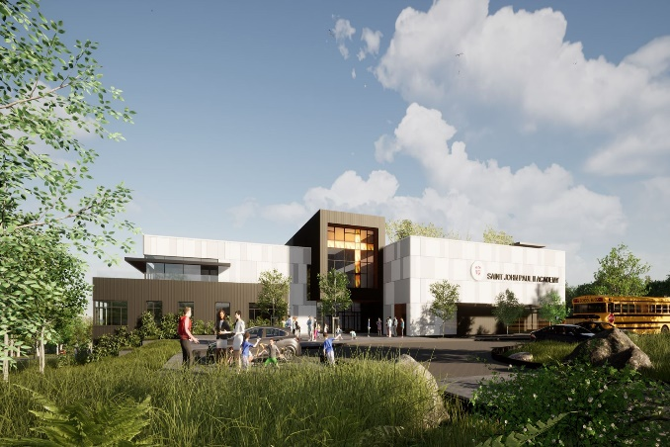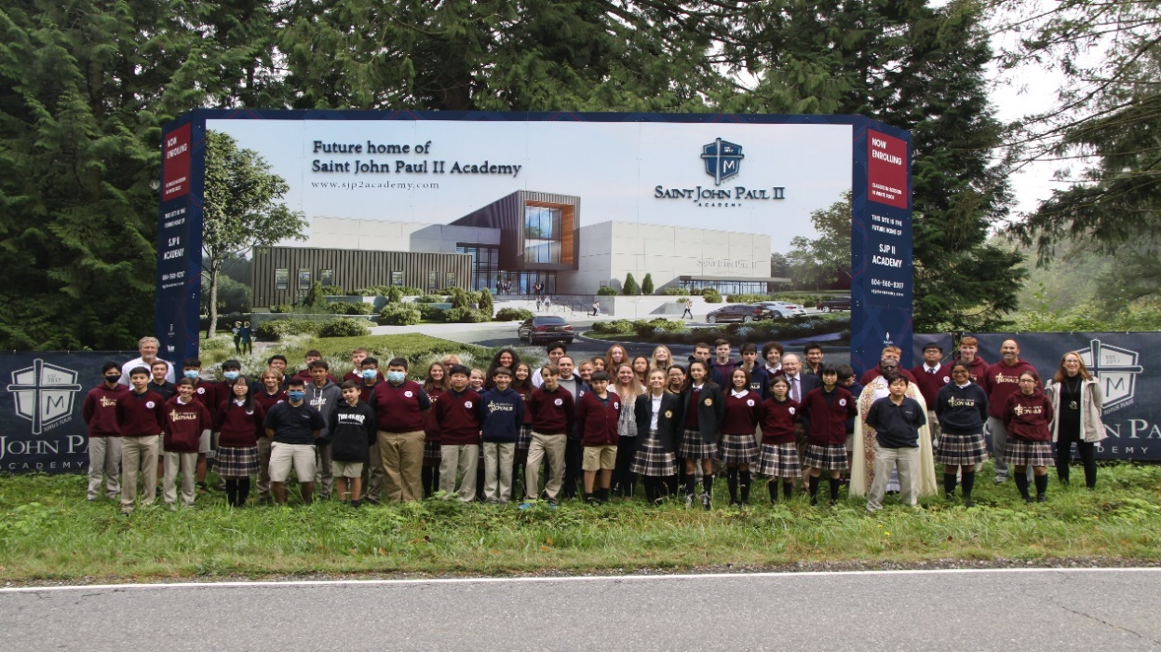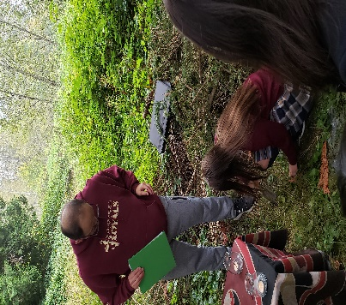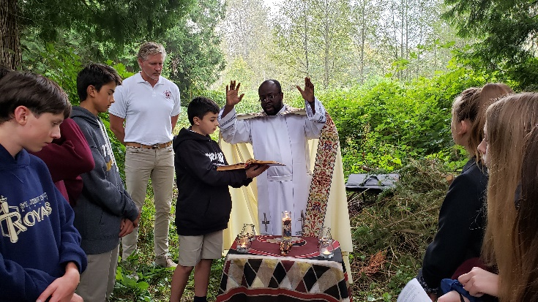

Staff and Students standing on the new building site at 182nd and 24th

Upcoming Virtual Information Evening (Questions and Answer Format)

Oct. 21st @ 6:30 pm via zoom

Please rsvp to Mrs. Susan Kelly if you are able to attend along with any questions you may have to: [skelly@sjp2academy.com](mailto:skelly@sjp2academy.com)

*We will be happy to send you the zoom link for the evening.*

Open House – Scheduled for Wed. Dec. 2nd @ 6pm at St. John Paul II Academy



UPCOMING INFORMATION EVENINGS:

WHEN: Jan. 29th; March 4th; April 8th ; May 20th @ 6:30 PM

WHERE: St. John Paul II Academy (Star of the Sea Parish Centre)

@ 6:30 pm at St. John Paul II Academy

.

Architectural Rendering of SJP II Academy

St. John Paul II Academy

Enter to Learn. Leave to Serve.

God. Family. School.

Join us for one of our virtual Information Evenings

Learn more about the newest school in Surrey

St. John Paul II Academy is a new Catholic High School beginning its third year of operation at our current location: The Star of the Sea Parish Centre. We have 48 students in Grade 8, 9, and 10 and are enthusiastically looking forward to another wonderful school year with limitless possibilities to overcome the challenges surrounding the current pandemic.

If you are looking for a high school that provides small classes in a safe and disciplined environment enabling your child to develop to their full potential and a school that provides an atmosphere permeated with Gospel values, then St. John Paul II Academy is the right choice for you and your family.

A strong bursary program has been put in place to assist families that may require financial assistance for tuition support.

Staff and the students with Fr. Guy at the Blessing Ceremony of the new high school location

Gr. 8 students burying a SJPII medal at the new building site



Principal: Mr. Michel DesLauriers ([mdeslauriers@sjp2academy.com](mailto:mdeslauriers@sjp2academy.com)) 15262 Pacific Ave. White Rock, B.C. V4B 1P7 P: 604.560.8210 www.sjp2academy.com

Principal: Mr. Michel DesLauriers ([mdeslauriers@sjp2academy.com](mailto:mdeslauriers@sjp2academy.com)) 15262 Pacific Ave. White Rock, B.C. V4B 1P7 P: 604.560.8210 www.sjp2academy.com

PrincipsPMjjjjPpMMMPPPPPP